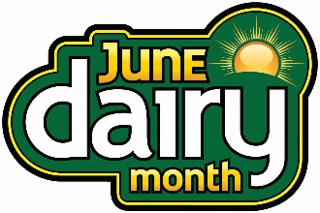
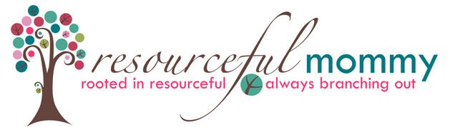

#JuneDairyMonth Twitter Party - Tuesday, June 9 at 8:00 p.m. ET

Q1: What products can you not live without from the #dairy aisle? #JuneDairyMonth
Q2: The #dairy aisle is full of products for every lifestyle – whether you want #organic, #plantbased or lactose free. What are your favorites? #JuneDairyMonth
Q3: From yogurt alternatives to cold brew coffee, what item(s) in the #dairy aisle have you considered buying, but haven’t tried yet? #JuneDairyMonth
Q4: The #dairy aisle is rolling in the dough! From biscuit dough to puff pastry, what dough shortcuts do you use when #cooking and #baking? #JuneDairyMonth
Q5: From orange juice and milk to flavored creamer for your coffee, what #drinks do you start your day with? #breakfast #drink #JuneDairyMonth
Q6: The #dairy aisle is bursting with versatile ingredients. From cream cheese to Greek yogurt, what refrigerated products do you use to up your foodie game? #JuneDairyMonth
Q7: We’re all about #snacking! What #snacks do you stock up on from the #dairy aisle? #snack #JuneDairyMonth
Q8: #Summertime is for cookouts! What is your favorite #summer #sidedish? #cookout #barbecue #BBQ #JuneDairyMonth
Q9: We’re all about delectable #meals! What is your most beloved #meal #recipe bursting with #dairy aisle ingredients? #JuneDairyMonth
Q10: We saved the best for last! What is your go-to #dessert to make during the #summer months? #desserts #JuneDairyMonth

