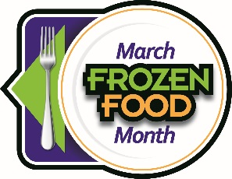
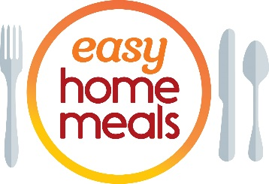
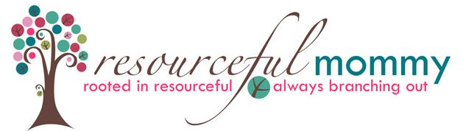

#FrozenFoodMonth Twitter Party - Tuesday, March 3 at 2:00 p.m. EST
Q1: March is National #FrozenFoodMonth! What #frozenfoods bring back memories from your childhood?

Q2: How do you use #frozenfoods to help you save money and waste less? #FrozenFoodMonth

Q3: From frozen waffles to grab-and-go sandwiches, what’s your go-to #breakfast that starts in the #freezer aisle? #FrozenFoodMonth

Q4: What #frozenfoods help you satisfy that craving for ethnic cuisine like Asian, Italian, Indian or Mexican? #FrozenFoodMonth

Q5: What frozen products do you find so convenient you couldn’t live without them? #FrozenFoodMonth

Q6: When you need to get #dinner on the table fast, what #frozenfoods make cooking on busy weeknights easier? #FrozenFoodMonth

Q7: From cauliflower pizza crust to plant-based meat, what’s the most innovative frozen product you’ve tried? #FrozenFoodMonth

Q8: What #frozen #snacks do keep stocked in your #freezer for when a #snack craving strikes? #FrozenFoodMonth

Q9: Whether gluten-free, high protein, low carb or vegan, what products help you meet your health goals? #FrozenFoodMonth

Q10: We’ve saved the best for last! From ice cream to pie, what’s your must-have #dessert or #treat? #FrozenFoodMonth

