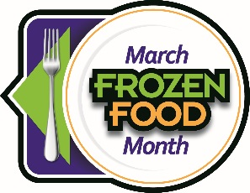
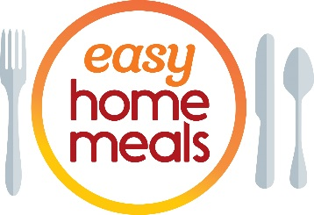
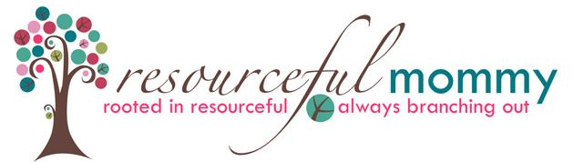

#FrozenFoodMonth Twitter Party - Tuesday, March 5 at 2:00 p.m. EST
Q1: March is National #FrozenFoodMonth! What #frozenfoods and products do you use to up your foodie game?
Q2: What #frozenfoods bring back memories from your childhood? #FrozenFoodMonth
Q3: How do you use #frozenfoods to help you waste less and save money? #FrozenFoodMonth
Q4: What’s your ultimate comfort food that starts in the #freezer aisle? #FrozenFoodMonth
Q5: What #frozenfoods do you find so convenient you couldn’t live without them? #FrozenFoodMonth
Q6: #Dinner in a hurry – what’s your go-to #frozen product that makes busy weeknights easier? #FrozenFoodMonth
Q7: What #frozenfoods help you satisfy that craving for ethnic cuisine like Asian, Italian, Indian or Mexican? #FrozenFoodMonth
Q8: From cauliflower rice to zucchini noodles, what’s the “coolest” and most innovative product you’ve tried? #FrozenFoodMonth
Q9: Whether low-carb, high protein, gluten-free or vegan, what products help you meet your health goals? #FrozenFoodMonth
Q10: We always save room for #dessert! From ice cream to pie, what’re your must-have #desserts or #treats? #FrozenFoodMonth

