Social Posts You Can Use With Your Audiences
- Arm your freezer with pre-packaged frozen veggies for a convenient snack or side dish at your fingertips — here’s six reasons to love frozen veggies: http://bit.ly/3GIEt9i

- Eating well doesn’t have to be expensive! Learn how to budget with nutritious frozen foods with our helpful infographic: http://bit.ly/3PcpvfB

- There’s no mystery, preserving food at the peak of freshness locks in key nutrients. Get a behind-the-scenes look from @EasyHomeMeals at the frozen food journey: http://bit.ly/WtfFqJ.

- Serve your family a delicious meal you can feel good about, like Squash “Spaghetti and Meatballs” from @EasyHomeMeals: http://bit.ly/35XLpkj

- When it’s time to fill your freezer after grocery shopping, put a purchase date on everything. After that, organize and rotate foods, putting newly purchased items in the back of the freezer. Then, use products on a "first in, first out" basis.

- Calling all smoothie lovers! Use pre-packaged frozen fruits in your smoothies so the washing, peeling, slicing and dicing is already done for you—plus you don’t need to add ice because it’s already cold.

- Did you know an average family wastes up to $2,200 per year on uneaten food? Fortunately, frozen foods can help reduce food waste. Learn ten ways you can reduce waste from @EasyHomeMeals: http://bit.ly/3iNsLlX
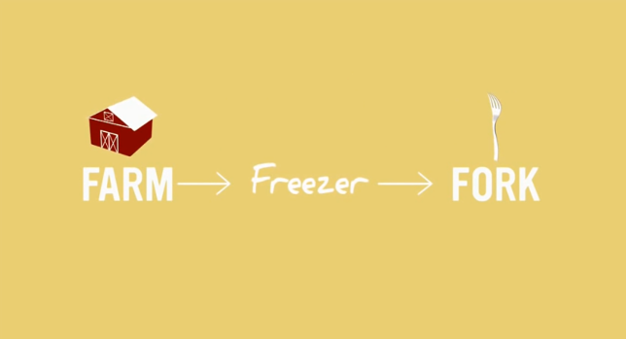
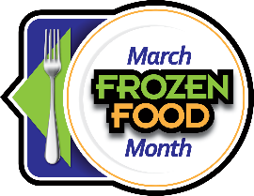
Plus, share the Frozen Foods: The Story from Farm to Fork video with your audiences! The video showcases the journey frozen foods make, from the farm to the kitchen table!

