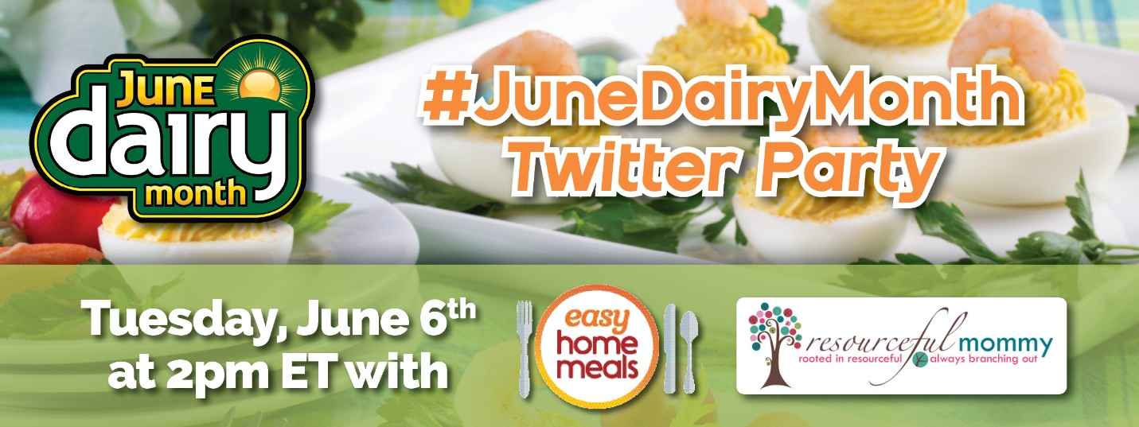
Questions That Will Be Tweeted During the Party
Prepare your answer tweets in advance!

Q1: We all have products we can’t leave the store without. What #dairy aisle items are essential in your household? #JuneDairyMonth

Q2. From #vegancheese to #oatmilk, the #plantbased options are endless in the #dairy aisle! What refrigerated plant-based products have you tried? #JuneDairyMonth

Q3: We've all heard that breakfast is the most important meal of the day! What #dairy aisle items make the mornings easier? #JuneDairyMonth
Q4. Warm weather calls for hosting! What crowd-pleasing #appetizers do you serve at summer gatherings? #JuneDairyMonth

Q5: When it comes to snacking, what #dairy aisle products have you going back for seconds? #JuneDairyMonth

Q6: With products like nut and oat milk and lactose-free yogurts, the refrigerated dairy aisle has an option for everyone! What are some of your go-to #dairyalternatives? #JuneDairyMonth

Q7. What better way to beat the summer heat than with a refreshing beverage, like lemonade! What is your drink of choice for hot days? #JuneDairyMonth
Q8. The #dairy aisle is packed with a variety of ingredients. From cheese to Greek yogurt, what refrigerated products do you use to prepare delicious #dinners? #JuneDairyMonth

Q9. Fire up the grill – it’s #cookout time! What summer #sidedish do you bring to a BBQ? #JuneDairyMonth

Q10: Let’s end on a sweet note! What’s your go-to #dessert during the summer months? #desserts #JuneDairyMonth

