Week 4: REIMAGINE MEAL SOLUTIONS

Social Post 1:

Last chance! It’s the final week to participate and enter for a chance to win a $100 gift card to your favorite grocery store.

🎁 With all the knowledge we have shared during the month, we’re sure you are excited to #ReImagine some new recipes using foods from the frozen and dairy aisles.

What’s your favorite unique recipe or meal idea that you’ve created or discovered using frozen and dairy foods? 🧀 ❄️ Share a photo with us of your new recipe, we’d love to see them!

Comment your answer with #ReDiscoverDairyandFrozen or follow the link to enter: http://bit.ly/3PceMlG

#ReDiscoverDairyandFrozen #EasyHomeMeals #ReImagine

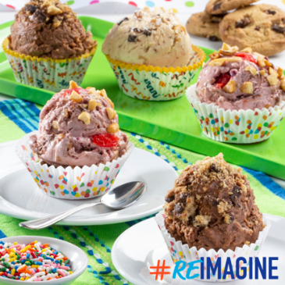
Social Post 2:

Tired of eating the same thing day after day? Don’t let food fatigue take over! Let’s #ReImagine mealtimes by exploring the dairy and frozen aisles.

With so many innovations to be found from new flavors, global cuisines, culinary inspirations, treats, and trendy new products to be discovered for breakfast, lunch, dinner, and dessert! 🔍

Try these plant-based treats for a modern twist on ice cream novelties! 🍦🍪 https://bit.ly/3VYe2m7

#ReDiscoverDairyandFrozen #EasyHomeMeals #ReImagine

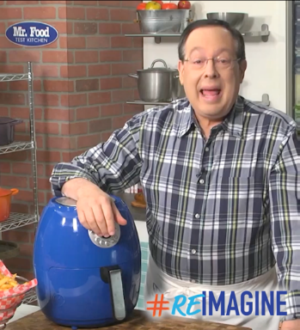
Social Post 3:

Are you looking to up your cooking game? Include an air fryer into your arsenal of kitchenware to help save time and clean up.

Cooking with an air fryer can open up endless meal possibilities. Let’s #ReImagine what dinner and snack time should look like.

Learn how an air fryer can make your cooking more adventurous! https://bit.ly/3F86PsR

#ReDiscoverDairyandFrozen #EasyHomeMeals #ReImagine
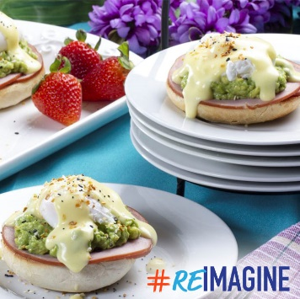
Social Post 4:

If you’re always craving something new and innovative, the dairy and frozen aisles are where you can find trendy flavor combos.
How about a breakfast classic with a twist? Break out of your comfort zone with our California-Style Eggs Benedict for your next brunch.

Don’t be shy, give it a try! 🍳 https://bit.ly/3P7zFhE

#ReDiscoverDairyandFrozen #EasyHomeMeals #ReImagine

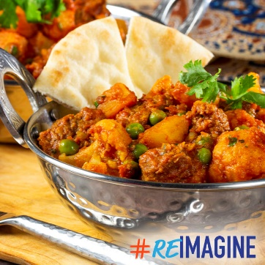
Social Post 5:

The variety of flavors, ethnic cuisines, and chef-inspired culinary inspirations you’ll #ReImagine in the cool aisles may leave you drooling. 😍

Let your taste buds take a journey with our Indian-Spiced Veggie Skillet full of authentic flavor with the familiar dinner you are used to. 🥦🍅
Add this recipe to your cookbook and impress your friends and family! 📘 https://bit.ly/3Y81ZVa
#ReDiscoverDairyandFrozen #EasyHomeMeals #ReImagine

