Week 3: REFRESH YOUR ROUTINE

Social Post 1: Giveaway

It’s giveaway time! Each week will have a fun new topic and your participation will enter you for a chance to win a $100 gift card to your favorite grocery store.
🎁 Don’t be shy, we know you are itching to share how you are going to #ReFresh your weekly meal routine.

What foods from the frozen and dairy aisles will you introduce to #ReFresh your weekly routine? 🧀 ❄️ Share a photo with us of your new meal plans.

Comment your answer with #ReDiscoverDairyandFrozen or follow the link to enter: http://bit.ly/3PceMlG

#ReDiscoverDairyandFrozen #EasyHomeMeals #ReFresh

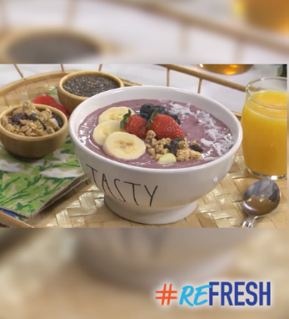
Social Post 2:

The new year is ripe for new beginnings and the perfect time to #ReFresh your meal routines. With help from the dairy and frozen aisles, you can find solutions to eat better. 💪

We can’t think of a better way to start the year off than with these protein-packed acai bowls! This is the perfect breakfast to ReDiscover what refrigerated and frozen foods can do for you.

Why not try it? Watch the recipe video here 👉 https://bit.ly/3iAg25C

#ReDiscoverDairyandFrozen #EasyHomeMeals #ReFresh

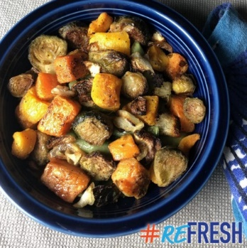
Social Post 3:

Looking to liven up your dinners? Want them to be more healthful, but still tasty? 🤔 The dairy and frozen aisles have you covered!

These aisles offer shortcut ingredients, ready-to-heat, and ready-to-eat solutions to #ReFresh all your meals.

Find our Sheet Pan Veggie Roast 🥕🧅 and more great recipes here! https://bit.ly/3UAf3j7

#ReDiscoverDairyandFrozen #EasyHomeMeals #ReFresh
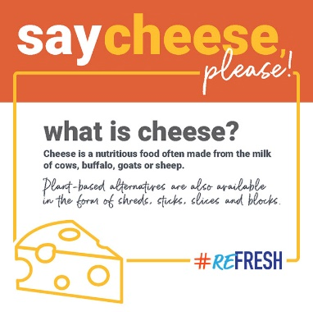
Social Post 4:

Let’s start the week off with everyone’s favorite: CHEESE! 🧀

Cooking with cheese is a great way to elevate any dish. Here are some of our best cheesy cooking tips.

🔶 When using cheese in a recipe, 1 cup of shredded cheese equals 4 ounces of whole cheese.
🔶 When melting cheese, add a little white wine or lemon juice before melting to help get a smooth and creamy texture.
🔶 When making your charcuterie board, remove cheese from the fridge 30 minutes to 2 hours before building your board for the optimum flavor.

You can read all our cheese hacks here! https://bit.ly/3uCsx3e

#ReDiscoverDairyandFrozen #EasyHomeMeals #ReFresh

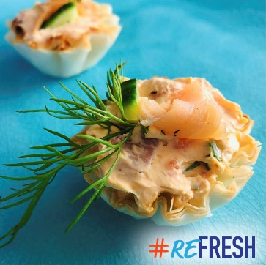
Social Post 5:

Looking to #ReFresh your meals and recipes to be more wholesome and tastier?

Keep your routine fresh with our savory Smoked Salmon Bites – full of flavor and guilt-free! 🍣

Save time while you focus on your health. Give our snack recipe a try! 🍴 https://bit.ly/3BkF9jA

#ReDiscoverDairyandFrozen #EasyHomeMeals #ReFresh

