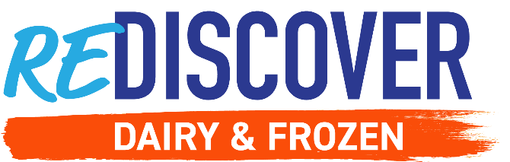

Week 2: RESTOCK YOUR FRIDGE & FREEZER

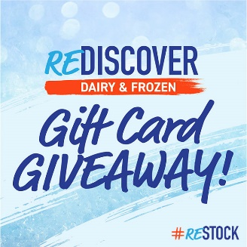
Social Post 1:

It’s giveaway time! Each week will have a fun new topic and your participation will enter you for a chance to win a $100 gift card to your favorite grocery store.

🎁 Now we KNOW you’re ready to #ReStock your fridge and freezer with delicious frozen and refrigerated options.

What frozen and refrigerated foods will you be adding to your fridge and freezer this year? 🧀 ❄️ Share a photo with us of your newly restocked fridge.

Comment your answer with #ReDiscoverDairyandFrozen or follow the link to enter: http://bit.ly/3PceMlG

#ReDiscoverDairyandFrozen #EasyHomeMeals #ReStock

Social Post 2:

Save time and make breakfast for today and tomorrow! 🕐 We can help stretch your dollar and get the most out of your grocery trips.

#ReStock your fridge with items that provide quick and delicious meals. Cooking ahead of time and freezing snacks and meals make a perfect re-heatable meal. 😍

Want to save time during your busy morning? Try this recipe here 👉 https://bit.ly/3uv7WOs

#ReDiscoverDairyandFrozen #EasyHomeMeals #ReStock

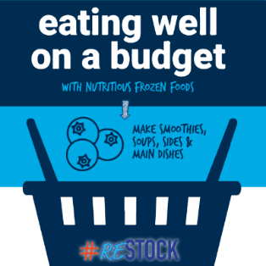
Social Post 3:

ReDiscover how the dairy and frozen aisles can help you #ReStock your fridge and freezer with convenient and nutritious options. 🔍

The best part: their products can be used for multiple meal occasions! 🥳

See our full list of the benefits frozen food can provide you and your family while eating well on a budget! ❄️ https://bit.ly/3PcpvfB

#ReDiscoverDairyandFrozen #EasyHomeMeals #ReStock
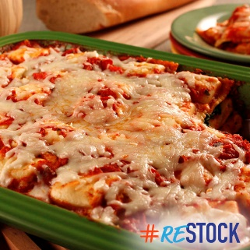
Social Post 4:

Easy meals for dinner that can provide you leftovers for the next day are ideal when you’re trying to make the most of your time.

Stock up on frozen pastas and cheeses to help make meals that can stretch through the week! And to get things started, here is our Layered Ravioli Bake recipe to make those weekdays a little bit easier.

Upgrade your food game here! 🍽 https://bit.ly/3Y4gQA4

#ReDiscoverDairyandFrozen #EasyHomeMeals #ReStock

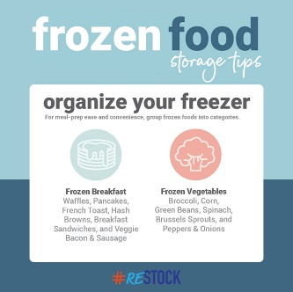
Social Post 5:

How often do you purchase frozen foods while grocery shopping? Did you know frozen products have a longer shelf life than fresh products? 🧊

Frozen foods should be stored at 0°F. It's best to buy what you can use within a few months to a year. ❄️

Learn more about frozen foods and proper storage tips to make the most of your grocery trips here 👉 https://bit.ly/3VZaX5n

#ReDiscoverDairyandFrozen #EasyHomeMeals #ReStock

