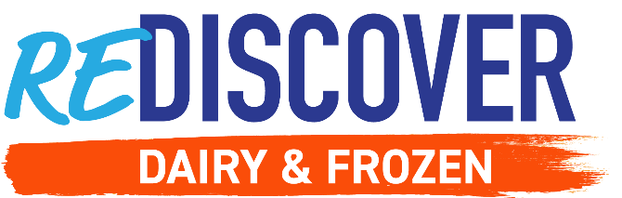

Week 1: RETHINK DAIRY & FROZEN

Social Post 1:

Cheers to a cool New Year! 🎉 ReThinking those eating habits? 👍 Then ReDiscover refrigerated dairy and frozen foods! It’s a month of ReConnecting with the aisles in a new way.

✅ Wholesome
✅ Innovative
✅ Convenient

Learn how you can ReDiscover dairy and frozen, and find out how you can win a $1,000 gift card here: http://bit.ly/3PceMlG

#ReDiscoverDairyandFrozen #EasyHomeMeals #ReThink

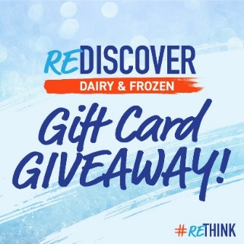
Social Post 2:

It’s giveaway time! Each week will have a fun new topic and your participation will enter you for a chance to win a $100 gift card to your favorite grocery store.

🎁 Now we KNOW you’re ReThinking those eating habits this New Year. So let’s hear them! 📣

What’s your Food-Years resolution? More veggies? 🥬 More meatless options? No-stress meals?

Comment your answer with the hashtag #ReDiscoverDairyandFrozen or follow the link to enter: http://bit.ly/3PceMlG

#ReDiscoverDairyandFrozen #EasyHomeMeals #ReThink

Social Post 3:

A complete dinner in minutes? Believe it! 😄

This Shrimp Scampi Flatbread is a full meal all in one. Delicious, nutritious, and super-fast, exactly what you want from dinner. 😍🍽

You can learn how to make it, plus find even more great recipes to help you #ReThink refrigerated and frozen foods. Make the flatbread 👉 https://bit.ly/3Y5X0nZ

#ReDiscoverDairyandFrozen #EasyHomeMeals #ReThink
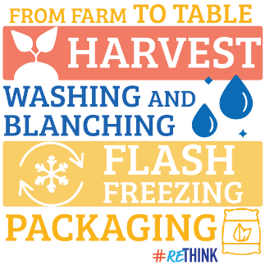
Social Post 4:

Are you worried about where your food comes from? 🤔 Where your food comes from matters and we understand that. No stress – just try the frozen and dairy aisles. ❄️🧊

There's a boatload of products with transparent ingredients and insights into their processes.

Learn how frozen produce goes from the farm to table here ➡️ https://bit.ly/3BhlKA0

#ReDiscoverDairyandFrozen #EasyHomeMeals #ReThink

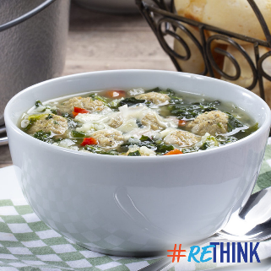
Social Post 5:

Sure, the frozen and dairy aisles are convenient. But did you know their products will thrill your taste buds AND fuel your body? 🤯

ReDiscover how they can help you hit your healthful meal goals this New Year! 🔍

Try this soup recipe for yourself! https://bit.ly/3PaL4gK

#ReDiscoverDairyandFrozen #EasyHomeMeals #ReThink

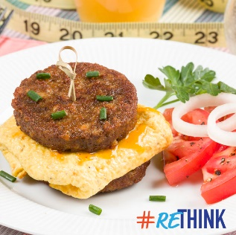
Social Post 6:

Easy. Nutritious. Breakfasts. 💪 They’re not a myth, thanks to frozen and refrigerated dairy foods! 😁

ReThink what they offer: wholesome, healthful, and high-quality foods to help your routine & budget 😋

Want proof? Try this vegetarian breakfast recipe here 🍽 https://bit.ly/3HhgyQk

#ReDiscoverDairyandFrozen #EasyHomeMeals #ReThink

