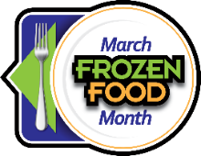
March Frozen Food Month Social Posts
You Can Use with Your Audiences

$10,000 Sweepstakes Posts:
- It’s March Frozen Food Month! Enter the $10,000 Sweepstakes from @EasyHomeMeals for a chance to win one a supermarket gift card! http://bit.ly/2RjlgTg
- Win big with the March Frozen Food Month $10,000 Sweepstakes from @Easy Home Meals! Enter today: http://bit.ly/2RjlgTg
- What would you buy if you won a supermarket gift card? Enter the $10,000 Sweepstakes from @EasyHomeMeals for a chance to win! http://bit.ly/2RjlgTg
- Time is running out, enter to win the March Frozen Food Month $10,000 Sweepstakes from @Easy Home Meals! http://bit.ly/2RjlgTg
Video Posts:
- Embrace the frozen food revolution this March! Let these Air Fryer Tips and Tricks from @EasyHomeMeals guide you through a culinary journey where time meets taste, making Frozen Food Month a flavor-packed adventure. https://bit.ly/3rqY7mU
- Discover the magic of frozen vegetables in "6 Reasons to Love Frozen Veggies" video from @EasyHomeMeals. https://bit.ly/34jGU3g
- Say goodbye to the dreaded freezer burn! Dive into this video from @EasyHomeMeals and discover 5 expert tips to ensure your ice cream stays perfectly preserved. https://bit.ly/3gwGitj
- There’s no mystery—preserving food at the peak of freshness locks in key nutrients. Get a behind-the-scenes look at the frozen food journey from @EasyHomeMeals. http://bit.ly/WtfFqJ
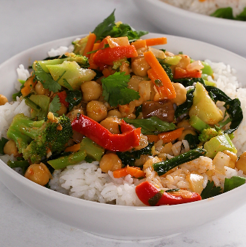
- March Frozen Food Month just got better with @EasyHomeMeals exclusive Weeknight Sampler – a delightful blend of convenience and flavor, bringing the best of the frozen aisle to your table. https://bit.ly/3l2EbUa

Recipe Posts:
- Make the most of March Frozen Food Month with @EasyHomeMeals Vegetable and Chickpea Coconut Curry. Effortlessly crafted with frozen spinach and frozen stir-fry veggies, it's a celebration of delicious convenience on your plate. https://bit.ly/3Qz4Pzu
- Dive into the convenience of March Frozen Food Month with Sheet-Pan Salmon by @EasyHomeMeals. Thaw, bake, and savor the delightful combination of tender salmon, aromatic dill, and a zesty lemony kick. https://bit.ly/3R1FRuh
- March Frozen Food Month calls for hassle-free meals! Try Frozen Cauliflower Florets with Romesco Sauce from @EasyHomeMeals – a simple sauté, a flavorful blend, and you've got an easy and delicious dish. https://bit.ly/46ezmsh
- Spice up March Frozen Food Month with @EasyHomeMeals mouthwatering Potsticker and Spinach Breakfast Strata! Frozen Chicken and Vegetable Potstickers take center stage in this cheesy, bacon-infused delight. https://bit.ly/3Seio9K
Tips Posts:
- Discover the joy of hassle-free meal planning with a well-stocked fridge and freezer, revolutionizing the way you approach breakfast, lunch, dinner, and snacks. Learn more: https://bit.ly/3tR5168
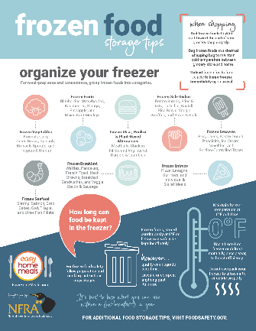
- Rethink your approach to cooking at home with the convenience of frozen foods, turning every meal into a culinary delight with minimal effort and maximum satisfaction. Find meal planning essentials here: https://bit.ly/41WgmOO
- Make every meal convenient and wholesome with frozen options. Whether it's calcium-packed dairy or whole-grain goodness, find it in the freezer aisles. Learn how frozen foods fit into a healthy lifestyle: https://bit.ly/3SdWljj
- Short on time or energy? Embrace the convenience of frozen foods for quick home meals—no washing, peeling, or chopping required. Discover simple hacks for easy meals at home: https://bit.ly/3TVvDxq
Follow EasyHomeMeals.com on Social Media:

- Facebook
- Instagram
- TikTok
- Pinterest
- Twitter
- YouTube

Hashtags to use during the March Frozen Food Month promotion:

- #FrozenFoodMonth
- #RealFoodFrozen

