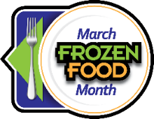
March Frozen Food Month Social Posts
You Can Use With Your Audiences

$10,000 Sweepstake Posts:
- It’s March Frozen Food Month! Enter the $10,000 Sweepstakes from @EasyHomeMeals for a chance to win one of eighteen $500 supermarket gift cards or grand prize $1,000 supermarket gift card. http://bit.ly/2RjlgTg
- Win big with the March Frozen Food Month $10,000 Sweepstakes from @Easy Home Meals! Enter today: http://bit.ly/2RjlgTg
- What would you buy if you won a supermarket gift card? Enter the $10,000 Sweepstakes from @EasyHomeMeals for a chance to win! http://bit.ly/2RjlgTg
- Time is running out, enter to win the March Frozen Food Month $10,000 Sweepstakes from @Easy Home Meals! http://bit.ly/2RjlgTg
Coupon Giveaway Posts:
- Happy Frozen Food Month! Enter the March Frozen Food Coupon Giveaway from @EasyHomeMeals for a chance to win frozen food coupons: http://bit.ly/2RjlgTg
- From now until March 31, enter the March Frozen Food Month Coupon Giveaway from @EasyHomeMeals for a chance to win frozen food coupons! http://bit.ly/2RjlgTg
- In celebration of March Frozen Food Month, @EasyHomeMeals is giving away frozen food coupons! Enter for your chance to win today: http://bit.ly/2RjlgTg
- Time is running out, enter the March Frozen Food Month Coupon Giveaway from @EasyHomeMeals today: http://bit.ly/2RjlgTg
Video Posts:
- Air fryers are all the rage. Check out these “5 Best Air Fryer Foods” in this quick video from @EasyHomeMeals. https://bit.ly/34FvTJ6
- How do I love thee frozen vegetables? Let me count the ways! Watch our “6 Reasons to Love Frozen Veggies” video from @EasyHomeMeals. https://bit.ly/34jGU3g
- Freezer burn is the worst! Check out these 5 expert tips for preventing freezer burned ice cream in this video from @EasyHomeMeals. https://bit.ly/3gwGitj
- There’s no mystery—preserving food at the peak of freshness locks in key nutrients. Get a behind-the-scenes look at the frozen food journey from @EasyHomeMeals. http://bit.ly/WtfFqJ
- Use frozen meatballs to make these out of this world Korean Sweet & Spicy Glazed Meatballs from @EasyHomeMeals! https://bit.ly/3rMRHMl

Recipe Posts:
- Did you know March is Frozen Food Month and Nutrition Month? This Lean & Green Smoothie from @EasyHomeMeals uses frozen spinach, pineapple chunks and mango chunks – so no chopping required! https://bit.ly/2KRIsI5
- When you’re stuck on what to make for dinner, look for inspiration from the frozen food aisle. This recipe for Creamy Chicken & Ravioli Skillet from @EasyHomeMeals uses frozen chicken, ravioli and peas, and pairs with frozen garlic breast sticks. https://bit.ly/3lg8Pp0
- Nothing can stack up against this scrumptious Peach Melba Pancake Stack from @EasyHomeMeals – starring frozen pancakes, raspberries and peaches. https://bit.ly/3sM2vYQ
- This Guilt-Free Buffalo Chicken Pizza from @EasyHomeMeals is made simple using a frozen cauliflower pizza crust and diced chicken. https://bit.ly/32W7qP9
If you like waffles and ice cream, then you’ll absolutely love this Waffle Cheesecake Supreme from @EasyHomeMeals. http://bit.ly/2Tsjb5Z
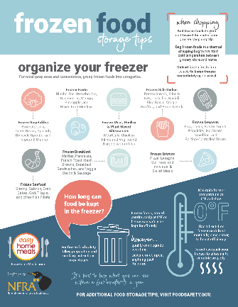
Tips Posts:
- Did you know that a jam-packed freezer isn’t a good idea? There needs to be room for proper air circulation. Find out more frozen food storage tips here: https://bit.ly/3uCu0YI
- Always keep your freezer at 0 degrees Fahrenheit or below. Check out more frozen food storage tips here: https://bit.ly/3uCu0YI
- Frozen fruits and vegetables are always in season – they’re picked at the peak of ripeness and flash frozen, locking in nutrition! Find out more: https://bit.ly/3LkdqCX
- With frozen fruits and veggies, the washing, peeling, slicing and dicing is already done for you. It goes from your freezer to your table in minutes! Learn more: https://bit.ly/3LkdqCX

Follow EasyHomeMeals.com on Social Media:

- Facebook
- Instagram
- TikTok
- Pinterest
- Twitter
- YouTube

Hashtags to use during the March Frozen Food Month promotion:

- #FrozenFoodMonth
- #RealFoodFrozen
- #frozenfood
- #frozenfood

