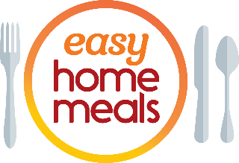
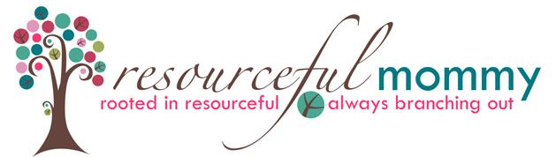
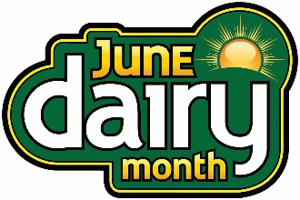

#JuneDairyMonth Twitter Party - Tuesday, June 7 at 2:00 pm ET

Q1: What #dairy aisle products are your must-haves during every shopping trip? #JuneDairyMonth

Q2: The #dairy aisle is full of products for every lifestyle – whether you shop lactose-free, #organic or #plantbased. What are your favorites? #JuneDairyMonth

Q3: From #vegan cheese to oat milk, what item(s) in the #dairy aisle have you considered buying, but haven’t tried yet? #JuneDairyMonth

Q4: #Summer is the season of #entertaining! From delicious dips to bite-sized apps, what do you look forward to eating most at parties? #JuneDairyMonth #appetizer

Q5: From unique #juice blends to #icedcoffee and flavored creamers, how do you step up your #beverage and #cocktail game? #JuneDairyMonth

Q6: The #dairy aisle is bursting with versatile ingredients. From cheese to Greek yogurt, what refrigerated products do you use to make delicious #meals? #JuneDairyMonth

Q7: We’re all about #snacking! What #snacks do you stock up on from the #dairy aisle? #snack #JuneDairyMonth

Q8: Summertime is for cookouts! What is your fave summer #sidedish or #salad to bring along? #cookout #BBQ #JuneDairyMonth

Q9: We’ve all heard it before – #breakfast is the most important meal of the day! What #dairy aisle shortcuts make the mornings easier? #JuneDairyMonth

Q10: Let’s end on a sweet note! What’s your top tasty #dessert to enjoy during the summer months? #desserts #JuneDairyMonth

