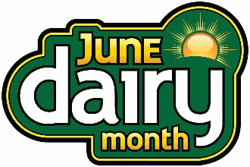
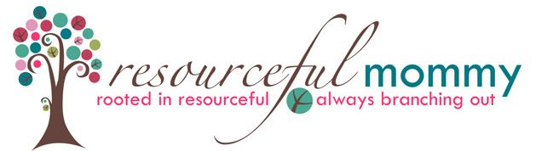
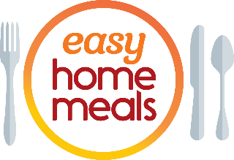

#JuneDairyMonth Twitter Party - Tuesday, June 1 at 2:00 p.m. ET

Q1: What #dairy aisle products do you buy during every shopping trip? #JuneDairyMonth
Q2: What #dairy aisle products help you meet your lifestyle and health goals – whether you want #organic, #plantbased or lactose free? #JuneDairyMonth
Q3: From #vegan cheese to oat milk, what item(s) in the #dairy aisle have you considered buying, but haven’t tried yet? #JuneDairyMonth
Q4: Got banana bread? #Baking has been all the rage this past year – what #dairy aisle ingredients are a must for your baking list? #JuneDairyMonth
Q5: From orange and fancy #juice blends to iced #coffee and flavored creamers, how do you up your #beverage and #cocktail game? #JuneDairyMonth
Q6: The #dairy aisle is bursting with versatile ingredients. From cheese to Greek yogurt, what refrigerated products do you use to make delicious #dinners? #JuneDairyMonth
Q7: We’re all about #snacking! What #snacks do you stock up on from the #dairy aisle? #snack #JuneDairyMonth
Q8: Summertime is for cookouts! What is your favorite summer #sidedish or #appetizer? #cookout #BBQ #JuneDairyMonth
Q9: We’ve all heard it before – #breakfast is the most important meal of the day! What #dairy aisle shortcuts make the mornings easier? #JuneDairyMonth
Q10: Let’s end on a sweet note! What’s your go-to delectable #dessert to enjoy during the summer months? #desserts #JuneDairyMonth

