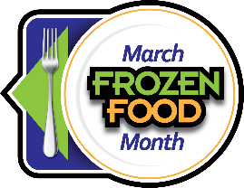
2025 March Frozen Food Month Social Media Toolkit
Campaign Theme: "Fresh Takes from Your Freezer"
Core Message Pillars: Core Message Pillars are the fundamental themes that should guide all your March Frozen Food Month content. Think of them as the foundation for every post you create. Here's how to use each pillar:
- Modern Meal Solutions: Content that shows how frozen foods fit into contemporary lifestyles
- Showcase work-from-home lunch ideas
- Highlight meal prep for busy professionals
- Feature quick assembly recipes
- Demonstrate time-saving techniques
Example Posts:
- "Turn frozen rice and vegetables into 3 different desk lunches 🍱"
- "No time to cook? Here's your 10-minute power bowl guide using frozen essentials"
- "Meal prep hack: Start with frozen grilled chicken strips for endless possibilities"
- Kitchen Creativity: Inspiring consumers to think differently about frozen foods
- Share unexpected combinations
- Show food styling techniques
- Create fusion recipes
- Offer plating tips
Example Posts:
- "Would you try this? Frozen meatballs become gourmet sliders in minutes!"
- "3 ways to transform frozen cauliflower into restaurant-worthy sides"
- "Build a beautiful charcuterie board using frozen appetizers"
- Smart Living: Content that emphasizes convenience, value, and practical solutions
- Share organization tips
- Offer shopping strategies
- Provide budget-friendly meal ideas
- Feature storage solutions
Example Posts:
- "Freezer organization 101: Here's how to maximize your space"
- "Smart shopper tip: Stock up on these frozen basics for endless meal options"
- "How to read frozen food labels like a pro"

- Family Moments: Content that connects frozen foods with family life and togetherness
- Feature kid-friendly recipes
- Share after-school snack ideas
- Highlight family dinner solutions
- Show weekend breakfast traditions
Example Posts:
- "After-school snack station featuring frozen fruits for smoothies!"
- "Sunday morning tradition: Build-your-own waffle bar with frozen toppings"
- "Kid-approved dinner hack: Frozen pizza gets a fun makeover"
- Seasonal Celebrations: Content that ties frozen foods to timely events and holidays
- Connect with March Madness
- Celebrate St. Patrick's Day
- Prepare for Easter
- Welcome Spring
Example Posts:
- "Game day spread made easy with frozen appetizers 🏀"
- "St. Patrick's Day party prep: Start with these frozen shortcuts ☘️"
- "Easter brunch planning? Here's your frozen food checklist 🐣"

Ready-to-Use Social Copy
Lifestyle Posts:
- ✨ Morning hack: Your freezer is the secret to stress-free breakfasts! What's your go-to morning freezer find? #FrozenFoodMonth
- 🏃‍♀️ Busy weeknight? Your freezer's got you covered! Share your favorite quick-fix dinner below #FreezerToTable
- 🎉 Weekend vibes = easy entertaining! Building the ultimate appetizer board with frozen favorites #HostingMadeEasy
Seasonal Posts:
- 🏀 Game day ready! Creating the ultimate March Madness spread from your freezer #MarchMadnessMunchies
- ☘️ Skip the crowds and celebrate St. Patrick's Day at home with these quick appetizers #StPatricksDay
- 🐣 Easter brunch planning made simple! Start with these frozen shortcuts #EasterMadeEasy
Kitchen Innovation Posts:
- 🌮 Taco Tuesday upgrade! Mix and match your frozen favorites for endless possibilities #TacoNight
- 🍳 Air fryer + frozen foods = dinner in minutes! What's your favorite air fryer hack? #AirFryerMagic
- 🥗 Building better bowls starts in the freezer! Create your perfect power bowl #BowlGoals
$10,000 Sweepstakes Posts:
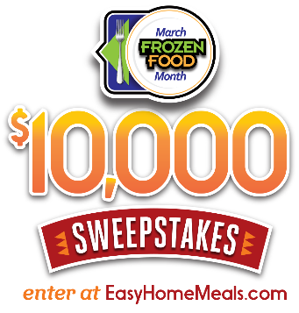
- It’s March Frozen Food Month! Enter the $10,000 Sweepstakes from @EasyHomeMeals for a chance to win one a supermarket gift card! http://bit.ly/2RjlgTg
- Win big with the March Frozen Food Month $10,000 Sweepstakes from @Easy Home Meals! Enter today: http://bit.ly/2RjlgTg
- What would you buy if you won a supermarket gift card? Enter the $10,000 Sweepstakes from @EasyHomeMeals for a chance to win! http://bit.ly/2RjlgTg
- Time is running out, enter to win the March Frozen Food Month $10,000 Sweepstakes from @EasyHomeMeals! http://bit.ly/2RjlgTg
Hashtags to use during the March Frozen Food Month promotion:

- #FrozenFoodMonth
- #RealFoodFrozen

Follow EasyHomeMeals.com on Social Media:
- Facebook
- Instagram
- TikTok
- Pinterest
- YouTube

