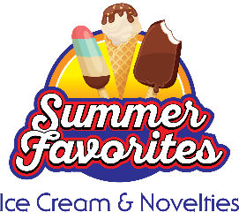
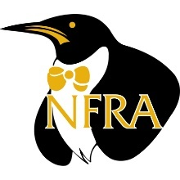

Social Media Content for 2023 Summer Favorites Ice Cream & Novelties

Follow EasyHomeMeals.com on social media:

- Facebook
- Instagram
- TikTok
- Pinterest
- Twitter
- YouTube

Hashtags to use during the June Dairy Month promotion:

- #NationalIceCreamMonth
- #IceCreamMonth
- #IceCream
- #SummerFavorites

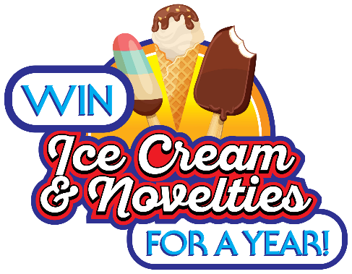
Ice Cream For a Year Coupon Giveaway:
- How would you like to win FREE ice cream for a year? Enter the Ice Cream For a Year Coupon Giveaway from @EasyHomeMeals! Enter today: https://bit.ly/3nRNxmV #IceCreamMonth
- Enter the @EasyHomeMeals Ice Cream For a Year Coupon Giveaway for a chance to win FREE ice cream and novelties for a year! https://bit.ly/3nRNxmV #IceCreamMonth
- Celebrate your love for #icecream and novelties— enter to win the Ice Cream For a Year Coupon Giveaway from @EasyHomeMeals! https://bit.ly/3nRNxmV #IceCreamMonth
- LAST CHANCE to enter to win the Ice Cream For a Year Coupon Giveaway from @EasyHomeMeals! https://bit.ly/3nRNxmV #IceCreamMonth #giveaway

Video Posts:
- Looking for an easy dessert? Grab your ice cream and whip up this 3 ingredient Crème Brûlée! https://bit.ly/42GsRgn #IceCreamMonth
- Don’t leave hot chocolate in the winter! This Peppermint Hot Chocolate Milkshake can be enjoyed all year-round. https://bit.ly/3nDlB6t #IceCreamMonth
- Dessert is in full bloom! Skip the flowers and serve this gorgeous ice cream bouquet. https://bit.ly/3VQ5BKE #IceCreamMonth
- Say goodbye to freezer-burned ice cream! Watch this video to learn how to properly store your ice cream and keep it fresh for longer. https://bit.ly/3LGxFeQ #IceCreamMonth
- Looking for a refreshing and light dessert option? This Strawberry Tart Frozen Yogurt recipe by @chefjamiegwen uses a few simple ingredients to whip up a treat that’s perfect for any occasion. https://bit.ly/3nLgxNf #IceCreamMonth
- Take your taste buds on a camping trip with these S’mores Ice Cream Balls. No campfire needed – just grab a spoon and get ready to melt! https://bit.ly/3nO9CD6 #IceCreamMonth

Recipe Posts:
- Cool down with this simple and delicious Not Fried “Fried” Ice Cream from @EasyHomeMeals. https://bit.ly/3J866K4 #IceCreamMonth
- Dairy-free lovers rejoice! Celebrate #IceCreamMonth with this rich and flavorful Oat Milk Ice Cream from @EasyHomeMeals. https://bit.ly/3gvVZAE #IceCreamMonth
- Milkshakes just got a whole lot bigger. This Monstrous Milkshake Madness recipe from @EasyHomeMeals will cure even the most intense sweet tooth. https://bit.ly/2Lsb9K0 #IceCreamMonth
- Indulge in the ultimate ice cream experience with a Twix Ice Cream Bar Cake from @EasyHomeMeals. With a layer of creamy vanilla ice cream, gooey caramel, and chocolatey Twix Ice Cream bars, this dessert will leave you wanting more. https://bit.ly/3crxeHE #IceCreamMonth
- Upgrade your classic ice cream sandwich with a chocolate dip! These Chocolate Dipped Ice Cream Sandwiches are the perfect treat for all sweets lovers. https://bit.ly/2w1Rwz0 #IceCreamMonth

Additional/Tip Posts:
- To keep your frozen foods in perfect condition, put the temperature in your freezer at 0 degrees Fahrenheit or below. #IceCreamMonth
- Did you know the average American eats 48 pints of ice cream per year? That is more than any other country! #IceCreamMonth
- Next time you grab a popsicle out of the freezer, you’ll know who to thank. The popsicle was invented by accident in 1905 by an 11-year-old named Frank Epperson. #IceCreamMonth
- Eating ice cream should be painless! Save the brain freeze by pressing your tongue to the roof of your mouth or drinking a glass of warm water. #NationalIceCreamMonth
- You should always keep your freezer at 0 degrees F to ensure your #icecream, #novelties and other frozen #treats taste their best! #IceCreamMonth #summerfavorites #tips
- Pack all #icecream and frozen #treats together in a reusable freezer bag to help maintain their cold temperature on the way home from the grocery store! #IceCreamMonth #tips
- June 20th: Today is #NationalIceCreamSodaDay! The #icecream soda was invented in Philadelphia in 1874 by Robert McCay Green, who ran a soda fountain at the Franklin Institute's semicentennial celebration. #IceCreamSodaDay
- July 23rd: Happy #NationalVanillaIceCreamDay! Sit back and enjoy a bowl of classic #vanillaicecream. #VanillaIceCreamDay #icecream
- July 25th: #NationalHotFudgeSundaeDay is every excuse you need to indulge in a #hotfudgesundae! #HotFudgeSundaeDay #icecream

