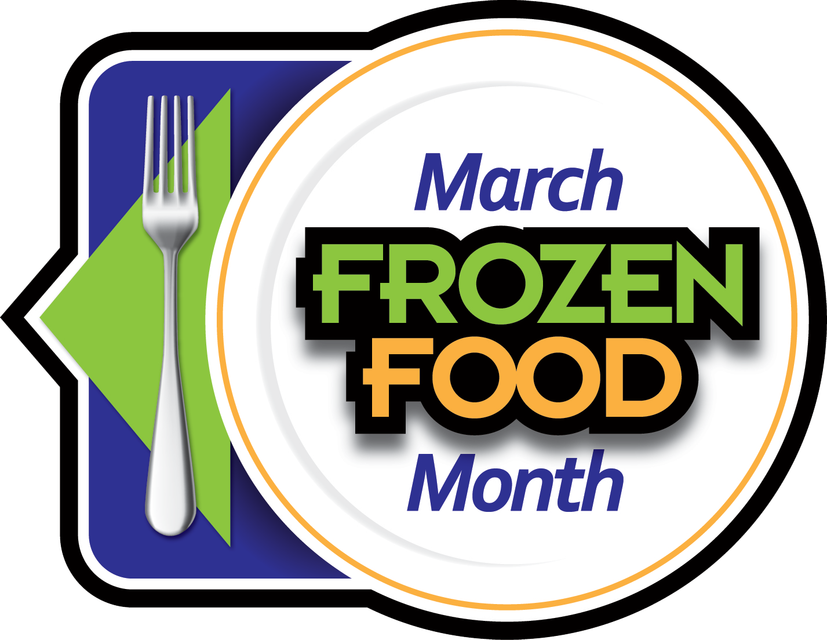

March Frozen Food Month Messaging

PROMOTION MESSAGES
- It’s March Frozen Food Month and the National Frozen & Refrigerated Foods Association is encouraging everyone to Savor the Taste of Real Food…Just Frozen!
- Enter for a chance to win a $1000 or $500 supermarket gift card in the March Frozen Food Month $10,000 Sweepstakes on EasyHomeMeals.com.
- Enter for a chance to win free frozen food in the March Frozen Food Month Coupon Giveaway on EasyHomeMeals.com!
- Follow Easy Home Meals on Facebook, Twitter, Instagram, TikTok and Pinterest throughout the month for cooking tips, videos and recipes.
- Find hundreds of simple and delicious recipes and meal ideas on EasyHomeMeals.com.

CORE KEY MESSAGES
- As dining habits and demands continue to change, the frozen food aisle is quickly expanding to meet those needs. With 3,700 frozen options to choose from, everyone from novice cooks and parents to chefs and foodies can create their own impressive food experience.
- Frozen foods cater to a wide variety of cultures and dietary requirements.
  - Today’s frozen foods are created and tested by chefs and nutritionists using on trend ingredients and flavors.
  - Whether you’re looking for vegan, ethnic, gluten-free, organic or antibiotic-free meat…the frozen food aisle has it all.
- Frozen foods last much longer than their fresh counterparts. Use just what you need and put the rest back in the freezer for next time – wasting less food and saving money.
  - Many frozen foods are perfectly-portioned so there’s no waste.
  - You are paying for 100% edible food – no stalks, seeds or rinds.
  - Frozen foods are consistently priced year-round
- Freezing is the best method for preserving food. Today’s quick freezing process freezes foods in just minutes stopping the clock and preserving all the nutritional value, freshness and flavor.
  - You can enjoy nutritious, quality fruits and vegetables year-round.
- Keeping your freezer stocked means delicious, quality foods are ready-to-use, making meal prep fast and easy.
  - All the picking, cleaning and chopping are already done, saving you time in the kitchen.

