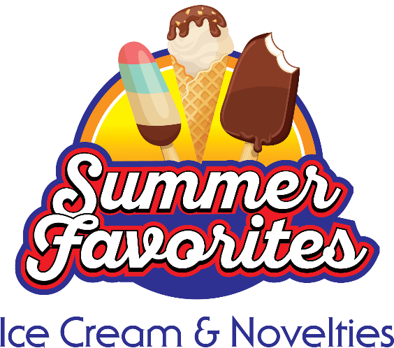

2022 Summer Favorites Ice Cream & Novelties Social Media Assets & Content

Below you’ll find social media content and assets, which will help you ignite conversation surrounding ice cream during the June/July Summer Favorites Ice Cream & Novelties promotion! Share these tips, social posts, ideas and recipes in your communications including newsletters, emails, on social media channels and on your website.

Follow the Easy Home Meals platforms:

- Website & Blog
- Twitter
- Facebook
- TikTok
- Pinterest
- Instagram
- YouTube

Hashtags to use throughout the Ice Cream promotion:

- #IceCreamMonth
- #NationalIceCreamMonth
- #icecream
- #summerfavorites
- #novelties

Ice Cream For a Year Coupon Giveaway
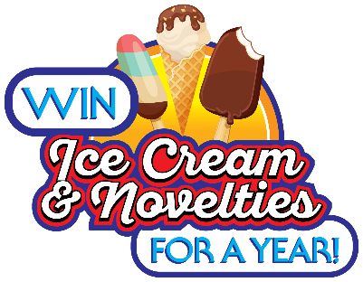
The Ice Cream For A Year Coupon Giveaway runs June 1st through August 2nd – promote to your audiences by sharing the giveaway logo and link (TBD) on your website, blog and social media channels.

Suggested Ice Cream & Novelties Social Media Content for NFRA Members
Facebook

- Starting 6/1 and ending 8/2: We all scream for COUPONS! Enter the Ice Cream For a Year Coupon Giveaway from @EasyHomeMeals! check back for link
- Starting 6/1 and ending 8/2: Enter the Ice Cream For a Year Coupon Giveaway from @EasyHomeMeals for a chance to win FREE ice cream and novelties for a year! check back for link
- Starting 6/1 and ending 8/2: Celebrate your love for summer favorites—enter to win the Ice Cream For a Year Coupon Giveaway from @EasyHomeMeals! check back for link
- Starting 6/1 and ending 8/2: How would you like to win FREE ice cream for a year? Enter the Ice Cream For a Year Coupon Giveaway from @EasyHomeMeals! check back for link
- Starting 6/1 and ending 8/2: LAST CHANCE to enter the Ice Cream For a Year Coupon Giveaway from @EasyHomeMeals for a chance to win ice cream for a year! check back for link
- Did you know July is National Ice Cream Month? Get inspired with ice cream recipes from @EasyHomeMeals! https://bit.ly/2T7sCK3
- In 1984, President Ronald Reagan designated July as National Ice Cream Month. What’s your favorite flavor of ice cream?
- We all scream for ice cream! Year over year ice cream is the best-selling frozen food category.
- Did you know the twin popsicle was invented during the Great Depression so two siblings could share an ice pop and only pay a nickel for it?
- RECIPE: You DO-NUT want to miss out on this Independence Day treat! Enjoy these festive Star-Spangled Ice Cream-Stuffed Donuts from @EasyHomeMeals. http://bit.ly/2QmwvrZ
- RECIPE: This light ‘n’ bright Strawberry-Lemon Ice Cream Tart from @EasyHomeMeals will keep you cool and smiling ear-to-ear! https://bit.ly/2Vexz51
- RECIPE: Everyone will be screaming for this Funfetti Ice Cream Sandwich Cake from @TheMillennialStayAtHomeMom and @EasyHomeMeals! https://bit.ly/3tXX9K6
- RECIPE: For a frozen treat the whole family can enjoy, blend up this alcohol-free Mudslide from @EasyHomeMeals. http://bit.ly/2Ya1kmF
- RECIPE: Turn your favorite breakfast treat into a luscious dessert with these Neapolitan Crepes from @MamaLatinaTips and @EasyHomeMeals! https://bit.ly/2XfnbLf
- What’s your favorite popsicle flavor? We bet you didn’t know that cherry is the most popular!
- It’s estimated 87% of Americans have ice cream in their freezer at any given time. What’s in your freezer?
- Feel like a kid again by enjoying a tasty ice cream sandwich, fudge bar or another frozen novelty.
- Did you know 1 ½ cups of ice cream equals one dairy serving? Scoop away!

- The average number of licks to polish off a single scoop ice cream cone is approximately 50. Challenge your family tonight to an ice cream licking contest!
- The world’s most popular ice cream topping is chocolate syrup. What’s your go-to topping?
- More ice cream is sold on Sunday than any other day of the week. Talk about a Sundae-Funday!
- Did you know the average American consumes around 48 pints of ice cream per year? That’s a LOT of ice cream!
- Year over year, vanilla ranks #1 in America. What’s your preferred ice cream flavor?
- Whether you’re looking for low calorie, high protein or dairy-free options, the ice cream aisle has it all.
- July 17th: Here’s the scoop… it’s National Ice Cream Day!
- Nobody likes melted ice cream—make the ice cream aisle your last stop at the supermarket!
- For best results, store ice cream in the main part of the freezer, not on the door where it is subject to more fluctuating temperatures.
- June 20th: Today is National Ice Cream Soda Day! Ice cream soda was invented in Philadelphia in 1874 by Robert McCay Green, who operated a soda fountain at the Franklin Institute's semicentennial celebration.
- You should always keep your freezer at 0 degrees F to ensure your frozen treats taste their best!
- July 23rd: There’s surely nothing vanilla about today—it’s National Vanilla Ice Cream Day!
- As temperatures heat up this summer, make sure you pack all ice cream and novelties together in a reusable cooler bag to help maintain their cold temperature on the way home from the store.
- July 25^{th:}: It’s National Hot Fudge Sundae Day! The perfect excuse to indulge in a hot fudge sundae!
- Did you know the popsicle was accidentally invented by 11-year-old Frank Epperson in 1905? Check out these Surprisingly Sweet Ice Cream Facts from @EasyHomeMeals: http://bit.ly/2XTISOt

Twitter
- Starting 6/1 and ending 8/2: We all scream for #COUPONS! #Enter the Ice Cream For a Year Coupon Giveaway from @EasyHomeMeals! check back for link #giveaway #coupon #icecream #giveawayalert #giveawaycontest #giveaways
- Starting 6/1 and ending 8/2: #Enter the Ice Cream For a Year Coupon Giveaway from @EasyHomeMeals for a chance to #win FREE #icecream for a year! check back for link #coupon #coupons #giveaway #giveawayalert #giveawaycontest #giveaways
- Starting 6/1 and ending 8/2: Celebrate your love for #icecream and novelties—#enter to #win the Ice Cream For a Year Coupon Giveaway from @EasyHomeMeals! check back for link #giveaway #coupon #coupons #giveawayalert #giveawaycontest #giveaways

- Starting 6/1 and ending 8/2: How would you like to #win FREE #icecream for a year?! #Enter the Ice Cream For a Year Coupon Giveaway from @EasyHomeMeals! check back for link #coupon #coupons #giveaway #giveawayalert #giveawaycontest #giveaways
- check back for link #coupons #giveaway #giveawayalert #giveawaycontest #giveaways
- Starting 6/1 and ending 8/2: LAST CHANCE to #enter to #win the Ice Cream For a Year Coupon Giveaway from @EasyHomeMeals! check back for link #icecream #coupon #coupons #giveaway #giveawayalert #giveawaycontest #giveaways
- Did you know July is #NationalIceCreamMonth? Get inspired with #icecream #recipes from @EasyHomeMeals! https://bit.ly/2T7sCK3 #IceCreamMonth #DYK
- In 1984, President Ronald Reagan designated July as #NationalIceCreamMonth! #icecream #IceCreamMonth
- Check out these Surprisingly Sweet Ice Cream Facts from @EasyHomeMeals: http://bit.ly/2XTISOt. #icecream #novelties #infographic #IceCreamMonth
- We all scream for #icecream! Ice cream is the best-selling #frozenfood category. #IceCreamMonth
- Did you know the twin #popsicle was invented during the Great Depression so two siblings could share a twin-pop and only pay a nickel? #IceCreamMonth #DYK #summerfavorites
- RECIPE: Get the #FourthofJuly #party started with these Star-Spangled Ice Cream-Stuffed Donuts from @EasyHomeMeals! http://bit.ly/2QmwvrZ #recipe #icecream #July4th #IndependenceDay #4thofJuly #dessert #donuts
- RECIPE: If you like strawberry lemonade, then you’ll love this zesty and sweet Strawberry-Lemon Ice Cream Tart from @EasyHomeMeals. https://bit.ly/2Vexz51 #icecream #dessert #desserts #recipe
- RECIPE: I scream, you scream, we’ll all be screaming for this Funfetti Ice Cream Sandwich Cake from @millennialsahm and @EasyHomeMeals! https://bit.ly/3tXX9K6 #icecream #cake #dessert #desserts #recipe
- RECIPE: For a frozen, alcohol-free #treat everyone can enjoy, blend up this Mudslide from @EasyHomeMeals. http://bit.ly/2Ya1kmF #icecream #recipe
- RECIPE: Whether for #breakfast or #dessert, you don’t have to travel to France to enjoy these luscious Neapolitan Crepes from @MamaLatina and @EasyHomeMeals! https://bit.ly/2XfnbLf #icecream #recipe #desserts
- Feel like a kid again by enjoying a tasty #icecream sandwich, fudge bar, sundae cone or other frozen novelty! #IceCreamMonth #summerfavorites #novelties
- It’s estimated 87% of Americans have #icecream in their freezer at any given time. What kind of ice cream or #novelties do you have in yours? #IceCreamMonth #summerfavorites
- Did you know the most popular #popsicle flavor is cherry? http://bit.ly/2XTISOt #IceCreamMonth #DYK #summerfavorites #novelties #infographic

- The average number of licks to polish off a single scoop #icecream cone is about 50. Challenge your family to an ice cream licking contest! #IceCreamMonth
- 1 ½ cups of #icecream, frozen yogurt and gelato equals one #dairy serving. #IceCreamMonth
- The world’s most popular #icecream topping is chocolate syrup. What’s your go-to topping? http://bit.ly/2XTISOt #IceCreamMonth #infographic
- We bet you didn’t know that California produces the most #icecream in America! #IceCreamMonth
- More #icecream is sold on #Sunday than any other day of the week. Talk about a Sundae-Funday! #IceCreamMonth #SundayFunday
- Did you know the average American consumes around 48 pints of #icecream per year? That’s a LOT of ice cream! http://bit.ly/2XTISOt #IceCreamMonth #DYK #infographic
- Year over year, #vanilla ranks the #1 #icecream flavor in America. What’s your preferred flavor? #IceCreamMonth
- Whether you’re looking for low calorie, high #protein or non-#dairy options, the #icecream aisle has it all. #IceCreamMonth #vegan #dairyfree
- July 17th: Here’s the scoop—it’s #NationalIceCreamDay! #IceCreamDay #icecream
- Did you know about 9% of all the #milk produced by U.S. #dairy farmers is used to make #icecream?! #IceCreamMonth #DYK
- Nobody likes melted #icecream—make the ice cream aisle your last stop at the supermarket! #IceCreamMonth #tips
- Store #icecream and other #novelties in the main part of the freezer, not on the door where it is subject to more fluctuating temperatures. #tips #IceCreamMonth #summerfavorites
- June 20th: Today is #NationalIceCreamSodaDay! The #icecream soda was invented in Philadelphia in 1874 by Robert McCay Green, who ran a soda fountain at the Franklin Institute's semicentennial celebration. #IceCreamSodaDay
- You should always keep your freezer at 0 degrees F to ensure your #icecream, #novelties and other frozen #treats taste their best! #IceCreamMonth #summerfavorites #tips
- July 23rd: Happy #NationalVanillaIceCreamDay! Sit back and enjoy a bowl of classic #vanillaicecream. #VanillaIceCreamDay #icecream
- Pack all #icecream and frozen #treats together in a reusable freezer bag to help maintain their cold temperature on the way home from the grocery store! #IceCreamMonth #tips
- July 25th: #NationalHotFudgeSundaeDay is every excuse you need to indulge in a #hotfudgesundae! #HotFudgeSundaeDay #icecream

