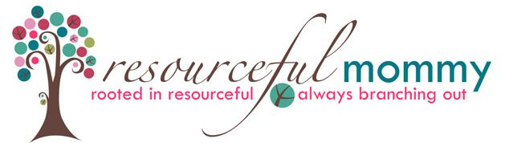
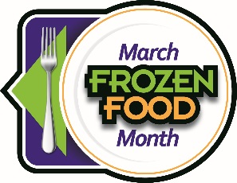
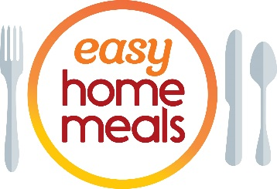

#FrozenFoodMonth Twitter Party - Tuesday, March 8 at 2:00 p.m. EST
Q1: March is National #FrozenFoodMonth! What #frozenfoods can you always find in your freezer?

Q2: Life’s short—eat #dessert first! What are your favorite #desserts or #treats from the #freezer case? #FrozenFoodMonth

Q3: From spring rolls to naan bread to taquitos to pierogies, what #frozenfoods help you satisfy that craving for ethnic cuisine? #FrozenFoodMonth

Q4: #Breakfast is the most important meal of the day. From frozen waffles to heat-and-go sandwiches, what frozen breakfasts get you out the door fast? #FrozenFoodMonth

Q5: Everyone is #snacking more than ever. What #snacks do keep stocked in your #freezer instead of reaching for the chips? #FrozenFoodMonth

Q6: From veggie fries to #plantbased pizza, what’s the most innovative frozen product that you’ve tried recently? #FrozenFoodMonth

Q7: What #frozenfoods do you turn to when you need some #meal inspiration? #FrozenFoodMonth

Q8: Whether #glutenfree, high #protein, low carb or #vegan, what frozen products help you meet your lifestyle and dietary goals? #FrozenFoodMonth

Q9: From frozen meatballs to pastry dough and veggies to ravioli, what frozen shortcuts do you utilize to make #meal prep easier? #FrozenFoodMonth

Q10: What frozen product(s) have you considered buying but haven’t yet? #FrozenFoodMonth

