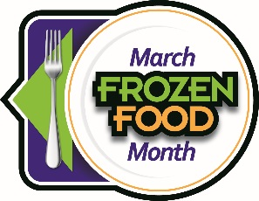
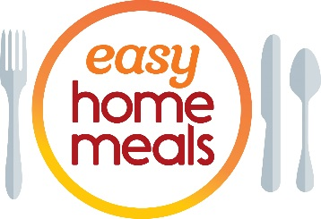
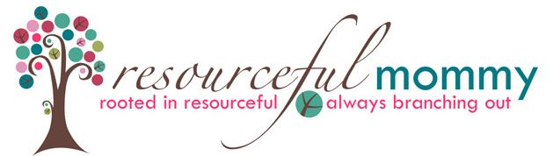

#FrozenFoodMonth Twitter Party - Tuesday, March 2 at 2:00 p.m. EST
Q1: March is National #FrozenFoodMonth! What #frozenfoods have you tried or stocked up on this past year while #cooking and spending more time at home?

Q2: What #frozenfood products do you find so convenient you couldn’t live without them? #FrozenFoodMonth

Q3: From frozen waffles to grab-and-go sandwiches, what frozen #breakfast items get you out the door fast? #FrozenFoodMonth

Q4: #Cooking fatigue is real this past year. What #frozenfoods do you turn to when you need some #meal inspiration? #FrozenFoodMonth

Q5: From veggies to pie shells, how do you use frozen ingredients to save money and time, and to create less #foodwaste? #FrozenFoodMonth

Q6: Americans are #snacking more than ever. What #snacks do keep stocked in your #freezer for when a #snack attack strikes? #FrozenFoodMonth
Q7: From potstickers and ramen bowls to taquitos and pad Thai, what #frozenfoods help you satisfy that craving for ethnic cuisine? #FrozenFoodMonth

Q8: Whether #glutenfree, high #protein, low carb or #vegan, what products help you meet your lifestyle and dietary goals? #FrozenFoodMonth

Q9: From cauliflower gnocchi to #plantbased breakfast sandwiches, what’s the most innovative frozen product that you’ve tried recently? #FrozenFoodMonth

Q10: We’ve saved the best for last! What’s your favorite #dessert or #treat from the #freezer case? #FrozenFoodMonth

